John Garcia’s Module 1.3 Assignment

Github Repo Link: <https://github.com/RUKtheCROOK/CSD-340>

Screenshot of broken html file:

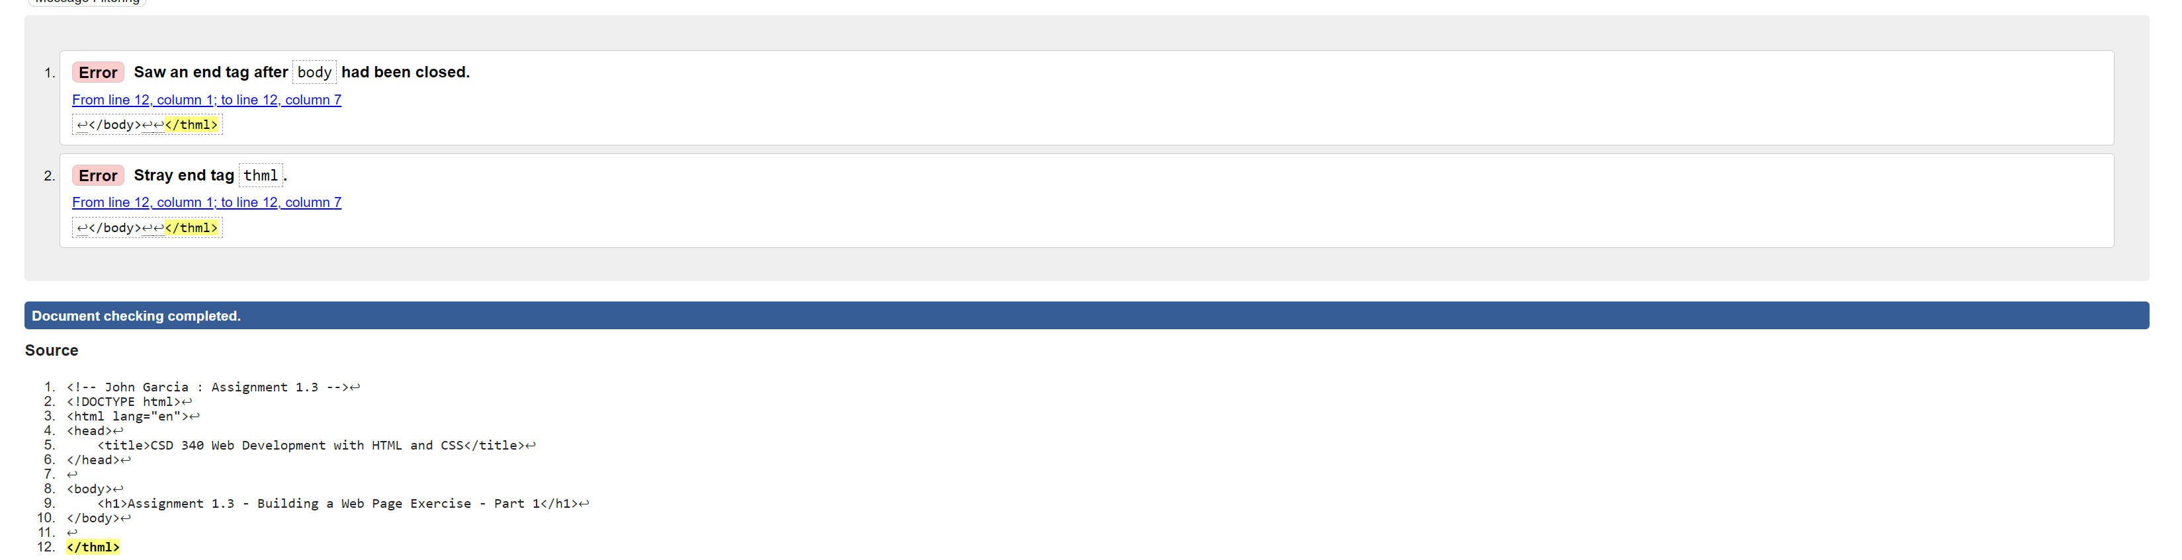

Screenshot of corrected html files:

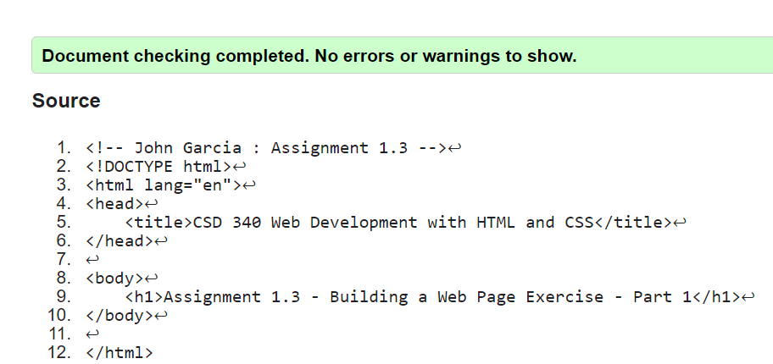

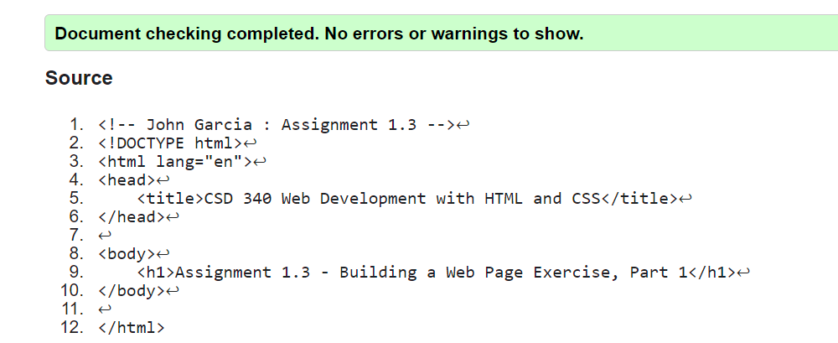

Screenshot of the file in the browser:

